Office Use Only: Application no.:_________

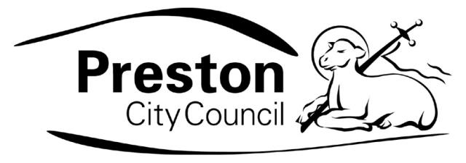
SMALL ARTS GRANT APPLICATION FORM 2010

Preston City Council’s small arts grants scheme offers grants of up to £400 to individuals, groups and organisations supporting artistic development activity and meeting the objectives of the 2008-2012 Arts Strategy in line with the Council’s current Corporate Plan. The scheme intends to support the development of cultural practitioners and organisations in Preston. Please read the grant guidelines listed on the final page of this application to ensure that your proposal meets the grant funding requirements before completing this application.
_ _ _ _ _ _ _ _ _ _ _ _ _ _ _ _ _ _ _ _ _ _ _ _ _ _ _ _ _ _ _ _ _ _ _ _ _ _ _ _
1. Please delete as applicable: a) Individual b) Group c) Organisation
2. If you answered ‘b’ or ‘c’ to Question 1, what is the name of your group,
or organisation?

3. Name of individual, or contact person for group/organisation and role
where relevant:

4. Address:

5. Post Code:

6. Daytime contact telephone number:

7. Email address:

8. Fax number:

PRESTON CITY COUNCIL
SMALL ARTS GRANT APPLICATION FORM 2010

Section 1

  - Title of the project:

£
  - Amount applied for:

  - Aims of the Individual, Group or Organisation (maximum 50 words) :

  - Status of the Group or Organisation (if applicable):

Registered Charity Company Ltd by guarantee

Voluntary Organisation Partnership

Individual Other

(Specify)

PRESTON CITY COUNCIL
SMALL ARTS GRANT APPLICATION FORM 2010/11

Section 2 – About the Project.

  - What do you want the small arts grant for?
(maximum 75 words)

  - Project start date (if applicable):

  - Project end date:
:

  - Who is the project for/ who will benefit?

  - Where will the project take place?

  - If this project is venue based, is the location accessible to disabled people?

Yes No

  - If you answered ‘no’ to question 2.6, what reasonable adjustments will you make to ensure maximum possible engagement by disabled participants/ audience?

  - How will you publicise the project to participants and
Audiences (where applicable)? (maximum 50 words)?

  - How will you know the project has been successful?

2.10 How many people will benefit?

Participants:

Audiences:

Other:
(please
specify)

  - Is anyone else (e.g. individual, group, local authority, sponsor) working with you on this project? If so, please give us details:

  - Does your proposal have any links to the Guild in 2012? Please explain if answering ‘yes’.

  - Have you received any grant funding from any department of Preston City Council or any other funding body within the last tax year? If so, please tell us who from and how much you have received?

PRESTON CITY COUNCIL
SMALL ARTS GRANT APPLICATION FORM 2010/11

Section 3 Project Budget Outline

3.1 Please give an itemised breakdown of the costs for this proposal (eg artist fees, training costs, travel expenses, materials). Attach, where appropriate, estimates of quotations. Please refer to small arts grants guidelines for what can and cannot be supported.

List each item separately:

Item Cost

Total: £_________________________.

3.2 How much are you asking the small arts grant scheme to fund?

3.3 What part of this proposal would you fund (this can include in-kind costs such as venues or materials)? Applicants are required to provide a minimum 10% contribution to the proposal.

3.4 If you do not receive the full amount, can the proposal still go ahead? What would be the effect?

Please note: constituted groups and organisations must include a copy of your most recent set of accounts.

Signed:

Position:

Date:

For office use only
Date applicaton Received | Advisory Group meeting date | Decision | Letter to applicant | Monitoring Form
 |  |  |  | Sent | Returned

Copies available from Preston City Council Cultural Development Manager: s.blackburn@preston.gov.uk
Where grant involves equipment purchase please note date when equipment will be purchased by.
April 2009 – March 2010

